1973-2025

2025 Oklahoma Sociological Association
Annual Conference & Meeting
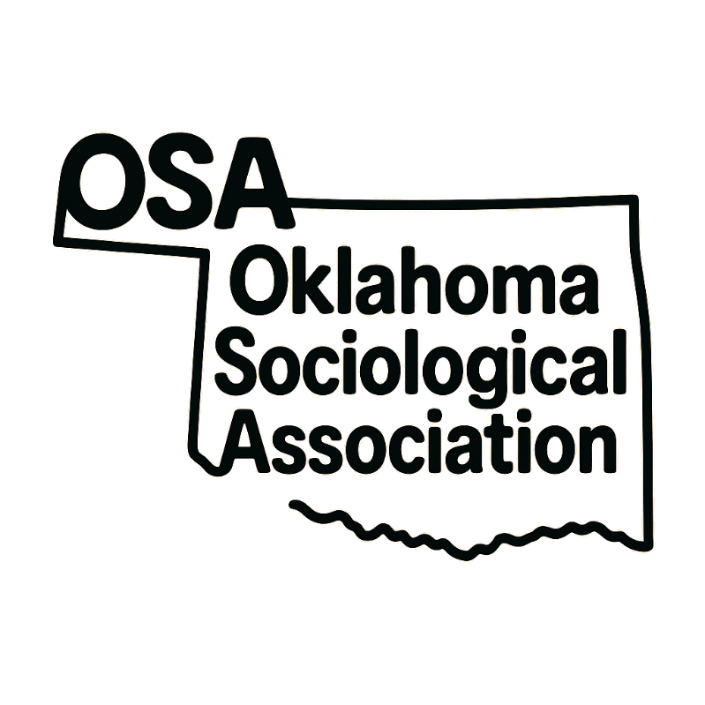
Understanding The Unhoused
Sponsored By UCO’s TADCA

November 7th, 2025
University of Central Oklahoma
Edmond, OK

OSA 2025 Special Guest & Keynote Speaker:

Jamie Caves

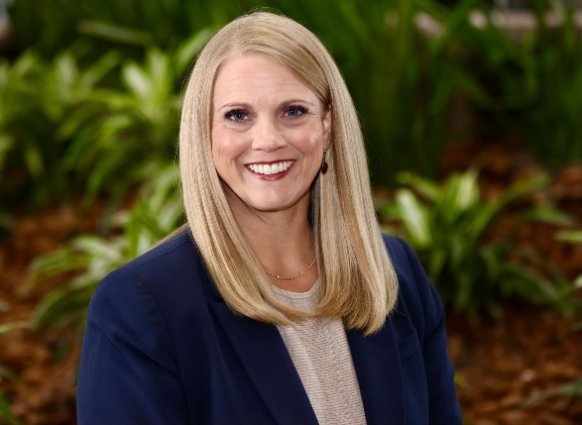

Jamie Caves has been an organizational leader for more than 20 years, dedicating the past decade to spearheading critical homelessness initiatives in Oklahoma City. Through her leadership at Sisu Youth Services, Jamie steered the creation of a volunteer-run shelter and completed a capital campaign project for a dedicated facility. Jamie joined the Key to Home Partnership in 2023 as the Homeless Strategies Implementation Manager, where she works with City leaders to refine and strengthen the homelessness response system across Oklahoma City.

8:00-8:30 - Sign in
8:30-9:50 - Break Out Session 1
A: Understanding the Unhoused - Carl Albert 300
Moderated By: Loren Ballard (UCO TADCA Secretary)
David Monk. “’Homelessness and Policing: Alternatives to Criminalization" (Oral Roberts University)
Corey Bradley. “Women Experiencing Homelessness and Crime” (Oklahoma State University)
Ara’Seli Salas. “Examining Perspectives of Police Assertiveness in Missing and Murdered Indigenous Women and Girls Cases” (Oklahoma State University)
Israt Juie. “Journeys of Emotion and Agency: The Lived Experiences of Married International Female Graduate Students at Oklahoma State University” (Oklahoma State University)

B: Social Control - Robert S Kerr 301
Moderated By: Brianna Montoya (UCO TADCA Vice President)
Brianna Branscomb. “Silenced Stories: Censorship and Morality in Texas Public School Libraries” (University of Texas at Arlington)
Anagha Rao. “Caste Identity and Political Conservatism in the Indian Diaspora” (University of Texas at Arlington)
Nicholas Membrez-Weiler. “The Dark side of managerial citizenship behaviors: the case of wage theft” (University of Oklahoma)
Belle Albert. “Breaking or Reinforcing Barriers? The Impact of Shifting Gender Expectations on Vertical Segregation Within the Profession of Law” (University of Texas at Arlington)
Jericho McElroy. “Qualifying Group Threat: Race, Region, and Restrictive Firearm Laws” (Oklahoma State University)

C. Interconnected Inequalities: Exploring the OKC Housing Crisis through a Sociological Lens (8:30 -9:30) - Heritage Room 326
Moderated By: Dawn Robertson (UCO TADCA President)
A panel discussion with UCO’s Sociology Club focused on the Oklahoma City housing crisis and the overlapping social issues that surround it. The discussion will illustrate how multiple forms of inequality intersect to shape the lived experiences of unhoused and low income residents in OKC.

10:00-11:00 - Keynote Address with Guest Speaker Jamie Caves (City of OKC’s Key to Home Partnership) - Heritage Room 326
11:00-11:25 - Business Meeting - Heritage Room 326
11:30-12:30 - LUNCH - Heritage Room 326
12:30-1:20 - Student Poster Presentation - Heritage Room 326

1:30-2:50 - Break Out Session 2
A: Climate Change and Environmental Justice - Carl Albert 300
Moderated By: Nina Privett (TADCA Public Relations Officer)
Chloe Jones. “Trust, Populism, and the Politics of Climate Concern” (University of Oklahoma)
Red Jones. Ayla Hutmacher. Amber Ottun. Kelly Bergstrand. “Climate Change, Who’s to Blame?: An Exploration of the Perceptions of Human Nature and Social Structures” (University of Texas at Arlington)
Lia Lawson. “Toxic Legacies and the Civilizing Process: Environmental Injustice in Oklahoma’s Abandoned Mines” (University of Central Oklahoma)
Saman Seyfi. “Entitled to the Earth: Aggrieved Entitlement, Economic Insecurity, and White Men’s Climate Attitudes” (University of Oklahoma)

B: Healthcare - Robert S Kerr 301
Moderated By: Loren Ballard (UCO TADCA Secretary)
Sarvenaz Amjadi. “Negotiating Health in a Gendered World: A Transnational Analysis of Women's Health and Habitus” (Oklahoma State University)
Dan Wang. Erin Maher. A.C. Ferraro. Sarah Connelly. “Measures of Caregiver Substance Abuse Problems and Types of Child Maltreatment” (University of Oklahoma & Sam Houston State University)
Brenda DuVerney-Chappell. “Doctor Misconduct: One patient’s story of the influence of power, status and money" (University of Central Oklahoma)
Calvin Easterling. “Cannabis in the U.S.: Risks, Benefits, and Equity Considerations” (Oral Roberts University)
Vinayak Jain. “Re-Constructing a Professional Identity: Impact of Cultural Capital on the training of International Medical Graduates” (University of Oklahoma Health Sciences Center)

C. Criminalizing Misery (1:30 to 2:30) - Heritage Room 326
Moderated By: Dawn Robertson (UCO TADCA President)
A panel discussion with Aidan Higgins and Meagan Taylor of the OK County Diversion Hub and University of Central Oklahoma’s FM Jones. Panel discussion focuses on The Misery-Punishment Nexus in Oklahoma City and its deleterious effects on OKC’s unhoused and marginalized communities.

3:00-4:20 - Break Out Session 3
A: Politics and Public Policies - Carl Albert 300
Moderated By: Brianna Montoya (UCO TADCA Vice President)
Nina Michalikova. “Big Bills, Bigger Questions: A Preliminary Look at Oklahoma Policymakers’ Responsiveness to Constituent Concerns about Poverty” (University of Central Oklahoma)
Peyman Hekmatpour. “The Longitudinal Analysis of Foreign Direct Investment Networks (2005-2023) and Their Impact on Climate Inequalities” (Oklahoma State University)
Alyson Stanoscheck. Dan Wang. “Impact of risk and protective factors on childhood behavioral problems across racially/ethnically minoritized children” (University of Oklahoma)
Thomas Burns. “Lessons on the Interplay sociology, human ecology, and religion: Insights from the past and suggestions for moving forward” (University of Oklahoma)

B: Theory and Methods - Robert S Kerr 301
Moderated By: Nina Privett (TADCA Public Relations Officer)
Asia Grimsley. “Reinventing the Future Through the Sociological Perspective” (Northern Oklahoma College)
Laura Bray. “Spatial Imaginaries and Rural Inequality in the Animal Welfare Movement” (University of Oklahoma)
Donna Sharp. “Revisiting Connection in Adolescent Girls through Their Use of Social Media” (Rogers State University)
Sara Moon-Seo. “From Reflection to Connection: Journey Mapping as an Engaging Tool for Classroom Learning” (Rogers State University)

Poster Presentations
- Aspen Osgood. Rachel Tate. Jonathan Garcia. Daniella Gentry. “Trauma, Faith, and Well-being: Exploring the Effects of Religious Experiences on Happiness and Family Satisfaction” (University of Oklahoma)
- Bentley Burger. Janae Donahue. Makayla Littlebear. Ella Thompson. “Money, Gender, and the Ballot: Examining How Income and Gender Influence Political Affiliation at the Polls” (University of Oklahoma)
- Chantel Eudave. Marissa Hernandez. Diego Morales. Maximillian Culp. “Religious Involvement and its Correlation to Pursuing Higher Education and Earned Income” (University of Oklahoma)
- Chris Moncayo. John Ryder. Jordan Scudday. Dillon Wagner. “Exploring the Effects of Criminal Convictions within Social Classes on Public Opinions of Court Proceedings and Police Spending” (University of Oklahoma)
- Cinthya Esquivel Rangel. Colin Hieronimus. Mia Villalon. Jon Wiseman. “Exploring the Effects of Regional Variation on Changing Class Identification” (University of Oklahoma)
- Emma Green. Presley Love. Jackie Townsend. Rachael Yett. “Faith, the South, and the Vote: Exploring the Effects of Religious Service Attendance and Southern Residence on Political Polarization” (University of Oklahoma).
- Ethan Bierwirth. Karla Hutcheson. Lola Sindjic. Syed Mohammad. “Born into Boxes: Exploring Sex and Race Based on Social Class and Income” (University of Oklahoma)
- Havah Alavi.“Biased Law or Biased System; An Analysis of the Effects of Bias in Child Welfare Cases” (University of Oklahoma)
- Kyndall Guest. Lila Lawrence. Grayson Bishop. Alexis Thelen.”Evaluating the Relationship Between Religiosity, Mental Health, and Confidence in Psychiatric Medicine” (University of Oklahoma).
- Md Shihabul Islam.“Existing Beyond the Gender Binary: Exploring Challenges and Coping Mechanisms of Hijra Community in Bangladesh” (Oklahoma State University)
- Paige Walko. Micaela Youngblood. Sophia Swift. Elaina Kellen. Marci Serrano. “Faith, Family, and The Mind: Exploring the Role of Religion and Family in Shaping Mental Health” (University of Oklahoma)
- Reagan Cole.“Examining Cultural Involvement and Mental Health Among Indigenous College Students: Preliminary Findings” (Oklahoma State University)
- Rebekah Williams. Wendy Avendano. Fernando Nuñez. “Stress and Masturbation (or the Lack Thereof): The Effects of Stress on the Masturbation Habits of College Students” (Northwestern Oklahoma State University)
- Seth Burney. Sam Marquez. Candice Bryant. Ava Jackson. “Money, Gender, and the Ballot: Examining How Income and Gender Influence Political Affiliation at the Polls” (University of Oklahoma)

Undergraduate Essay Participants
- Abby Douglas (Northern Oklahoma College)
- Ansleigh Barnes (Northern Oklahoma College)
- Ashley guzman (Northern Oklahoma College)
- Brady Wood (Northern Oklahoma College)
- Brandy Gober (Northern Oklahoma College)
- Caden Ehardt (Northern Oklahoma College)
- Cristal Cain (Northern Oklahoma College)
- Danika Pearson (Northern Oklahoma College)
- Derrek Daugherty (Northern Oklahoma College)
- Dorothy Paulis (Northern Oklahoma College)
- Hali Tuell (Northern Oklahoma College)
- Heather Young (Northern Oklahoma College)
- Hollis Horstman (Northern Oklahoma College)
- James Swenson (Northern Oklahoma College)
- Joceline Bautista (Northern Oklahoma College)
- Joely Gonzales (Northern Oklahoma College)
- Karen Miranda (Northern Oklahoma College)
- Kayla Hundley (Northern Oklahoma College)
- Kenley Lemons (Northern Oklahoma College)
- Kennedy Zook (Northern Oklahoma College)
- Kimberly Portillo (Northern Oklahoma College)
- Maci Nevels (Northern Oklahoma College)
- Madison Maluy (Northern Oklahoma College)
- Marcus Tolbert (Northern Oklahoma College)
- Marlin Mawilong (Northern Oklahoma College)
- Michael Brucker (University of Oklahoma)
- Michelle Brays (Northern Oklahoma College)
- Morgan Peeper (Northern Oklahoma College)
- Moriah Forbeck (Northern Oklahoma College)
- Nora Garcia (Northern Oklahoma College)
- Raymond Nazario (Northern Oklahoma College)
- Rita Lopez-Ramirez (Northern Oklahoma College)
- Sadie Lopez (Northern Oklahoma College)
- Sarah Todd (Northern Oklahoma College)
- Savannah King (Northern Oklahoma College)
- Staysha Cummins (Northern Oklahoma College)

The Oklahoma Sociological Association would like to thank TADCA and the following volunteers for helping to make this year’s conference a success:
LaDonna McCune Ed.D (UCO) TADCA Sponsor and Poster Contest Judge
Dawn Robertson (UCO) TADCA President and Moderator
Brianna Montoya (UCO) TADCA Vice President and Moderator
Loren Ballard (UCO) TADCA Secretary and Moderator
Nina Privett (UCO) TADCA Public Relations Officer and Moderator
Peyman Hekmatpour PhD (OSU) Poster Contest Judge
Fred Jones PhD (UCO) Poster Contest Judge
Emma Green (OU) Sign in Table Operator
Presley Love (OU) Sign in Table Operator
Jackie Townsend (OU) Sign in Table Operator
Rachel Yett (OU) Sign in Table Operator
Aspen Osgood (OU) Sign in Table Operator
Rachel Tate (OU) Sign in Table Operator
Karla Hutcheson (OU) Sign in Table Operator
Syed Mohammad (OU) Sign in Table Operator
Chris Moncayo (OU) Sign in Table Operator
Jordan Scudday (OU) Sign in Table Operator.
Kyndall Guest (OU) Sign in Table Operator
Lila Lawrence (OU) Sign in Table Operator

