 Poster Presentations 
Anna Birgitta Nilsson, Ron Cremers, Korbin Hammack, & Kyla Laurent. “Rules For Thee Not For Me: How Socioeconomic Status Affects Attitudes towards Reproductive Rights” (University of Oklahoma)
Brooke Schutrum. “The Micro-Sociology of Violent Situations: Violence and Confrontational Tension in Civil Protests” (University of Oklahoma)
Cynthia Keeth. “Influences in the Development of Feminist Consciousness” (Southeastern Oklahoma State University)
Daniel Garcia Jr. "And How Does that Make you Feel? Exploring Race's Role in Mental Health" (University of Oklahoma)
Ethan Weaver, Jack Yager, Wenayv Yates, & Lance Young. “The Prestige Effect: Understanding the Influence of Racial Differences in Work Pathways” (University of Oklahoma)
Katarina Ross, Sofia Ward-Jimenez, & Dakotah Scruggs. “Degree of Wellness: How Educational Attainment Shapes Mental Health” (University of Oklahoma)
Katlynn Miller “Micro-Sociological Analysis of a Violent Interaction of Six Flags St. Louis” (University of Oklahoma)
Kayla Ptak, Carolina Herrera, Marcus Hulsey, & Vanessa Soric Dodig. “Attitudes Toward the Justice System: How Race, Ethnicity, and Class Shape Views on Capital Punishment and Law Enforcement Funding” (University of Oklahoma)
Kristin Folsom, Angel Richmore, Eric Green, Ezra Felix. “Unequal Justice: Race, Class, and Views on the Death Penalty” (University of Oklahoma)
Marika Condray, Chloe Jones, Tori Hackenberger, & Lilah Fitzner. “Neoteric Degree: Investigating the Effects of Degree Attainment on Progressive Gender Attitudes” (University of Oklahoma)
Mikaylee Ribble. “From the Capital to our Community: A Micro-sociological Perspective on Violence” (University of Oklahoma)
Paige Aldrich, Brooklyn Haase, Jordyn Millhouse, & Lesley Alvarado. “The X-Factor: Analyzing the Effects of Movie Content on Risky Behaviors” (University of Oklahoma)
Paige Vannoy, Sam Armstrong, Ally Edgar, & Issac Perry. “Spare the Rod: The Effects of Education and the Perceptions of Corporal Punishment” (University of Oklahoma)
Suknya Banwait. “Paternal Parenting Stress and Problem Behaviors: An investigation among Young Chinese Children” (University of Oklahoma)
Vivienne Sweet, Mikaylee Ribble, Emily Carrasco, & Stephanie Sanchez. “Exploring the Role of Socioeconomic Factors in Shaping Perceptions of Race and Racial Discrimination Among White Americans” (University of Oklahoma)
 Undergraduate Essay Participants 
Jazzlyn Jones (Oklahoma State University Oklahoma City [OSU-OKC])
Katlynn Miller (University of Oklahoma)
Luke Sinclair (Northwestern Oklahoma State University)

 1973-2024 

2024 Oklahoma
Sociological Association
Annual Conference

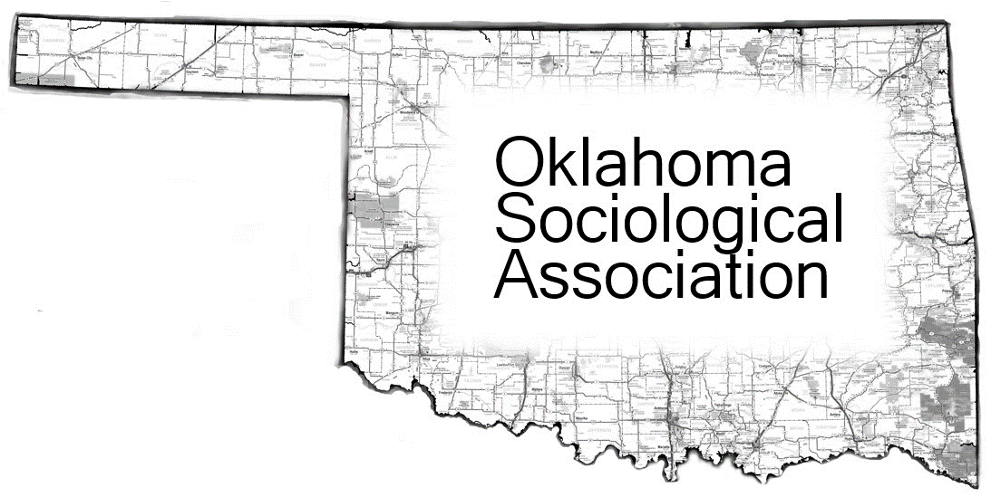

“Reimagining the Future
of Individuals, Families,
and Communities”

November 15, 2024

University of Oklahoma

Norman, OK

Thurman J. White Forum Building
1704 Asp Avenue, Norman, OK 73072

Oklahoma Sociological Association
 1973-2024 

8:00-8:30 - Sign in
8:30-9:50 - Break Out Session 1
A: Climate and Environment - B1/3 Suite
Christopher Garneau. “’I’ll See It When I Believe It:’ Examining How Politics and Climate Change Belief Impact Accuracy in Severe Weather Event Recall” (University of Oklahoma)
Prithila Purkayastha. “The Inclusiveness Agenda: An Analysis of the Disaster Management Regulatory Framework of Bangladesh” (Boise State University)
Charles Spurlock. “Black Environmental Behavior and Value Orientation” (Langston University)
Peyman Hekmatpour. “Ecologically Unequal Exchange and Renewable Energy Adoption Rate: A Cross-National Study of 144 Countries (2000-2019)” (Oklahoma State University - Tulsa)
B: Gender and Sexuality - B2/4 Suite
Mashaekh Hassan. “An Exploratory Look into the Increasing Visibility of Queer-themed Content: Dhaka-based, Youth-dominated Social Media Platforms” (Florida Atlantic University)
Resat Amin. “Social Media as a Battleground: A Qualitative Analysis of the Representation and Resistance of Feminist Activism in Bangladesh” (Florida Atlantic University)
Nina Michalikova. “Empowered Choices: Family Reactions to Female Bodybuilders Stepping on Stage” (University of Central Oklahoma)
Zachary Guinn. “Women’s Rites: Strip Clubs as Ritual Self-formation Spaces” (University of Texas at Arlington)
10:00-11:00 - Sociology Keynote Speaker - Conference Room B
Dr. Samuel Perry. “Culture Wars and Multiethnic Coalitions of Exclusion: How MAGA Recruits Black and Latino Support” (University of Oklahoma)
11:00-11:25 - Business Meeting - Conference Room B
11:30-12:30 - LUNCH - Conference Room B
12:30-1:20 - Student Poster Presentation - Conference Room B
1:30-2:50 - Break Out Session 2
A: Higher Education and Pedagogy - B1/3 Suite
Sara Moon-Seo & Jessica McBrien.“Collaborative Learning in Creating a Syllabus in Higher Education” (Rogers State University)
Anagha Rao, Red Jones, & Mercy Ogunmoyin. “Who Picks My Major?: A Study on Gendered Choices of College Majors” (University of Texas at Arlington)
Thomas Burns. “Bridges to Understanding and Tolerance: Teaching about World Religions & Society in the Third Millennium” (University of Oklahoma)
B: Individuals and Families - B2/4 Suite
Calvin Easterling. “Building on Durkheim: Confronting Suicide in the US Military” (Oral Roberts University)
Keith Killian. “Gray, Bald, and Broken. Addiction among the Elderly” (University of Central Oklahoma)
Donna Sharp. “ACES and Identity: Identity Development in Adolescent Girls with Adverse Childhood Experiences” (Rogers State University)
Brenda DuVerney-Chappell. “Negative Life Outcomes from Physical and Sexual Abuse” (University of Central Oklahoma)
3:00-3:50 - Break Out Session 3
A: Politics and Public Policies - B1/3 Suite
Elizabeth McElroy. “The Relative (Non) Importance of Abortion Among 2020 Election Issues and Swing Voters' Candidate Choice” (Indiana University - Bloomington)
Aishwarya Ahmed. “Exploring Patron-Client Relationship in Student Politics in Bangladesh: The Case of University of Dhaka” (Oklahoma State University)
Jericho McElroy. “Determinants of Summative Handgun Law Provisions across U.S. States, 1992-2019" (Oklahoma State University)
B: Theory and Methods - B2/4 Suite
Sakin Erin.“The BRICS+ and the Middle-Run Futures of the Global System” (University of Science and Arts of Oklahoma)
Kyle McNew. “The Doctrine of Double Effect” (Oregon State University)
Thomas Burns & Cyrus Schleifer. “The Price of Being Wrong: Rethinking Normal Methods for Post-Normal Times” (University of Oklahoma)

